Working with http

Node.js is having http, https and tcp modules available.

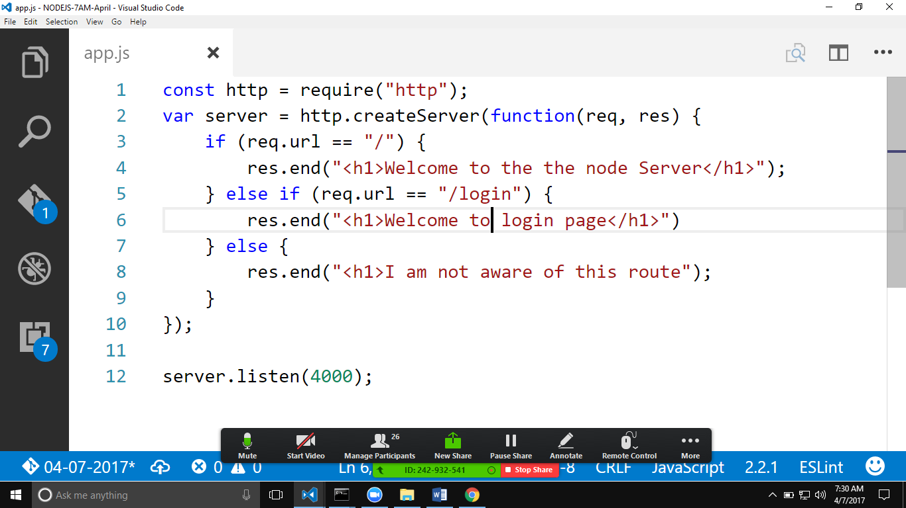

Tip: to restart the server automatically on a js file change we can use **nodemon**

**“npm install -g nodemon” one time setup.**

**“nodemon app.js”**

The above code will offer a server and the server will be running on the port 4000.

Based on the http module below frameworks are developed.

1. Expressjs
2. Hapi
3. Koa
4. Sails.js
5. Strong loop.
6. Meteor.js